Cell Size
What determines the size of a cell?
Why?
Sometimes bigger is better—tall basketball players, more closet space, and savings accounts may come to mind. What about cells? Does having big cells make an organism bigger or better? Would having larger cells be an advantage to an organism? If so, why do cells divide rather than continue growing? Maybe there is an advantage to being small.
Model 1 – Investigating Cell Size
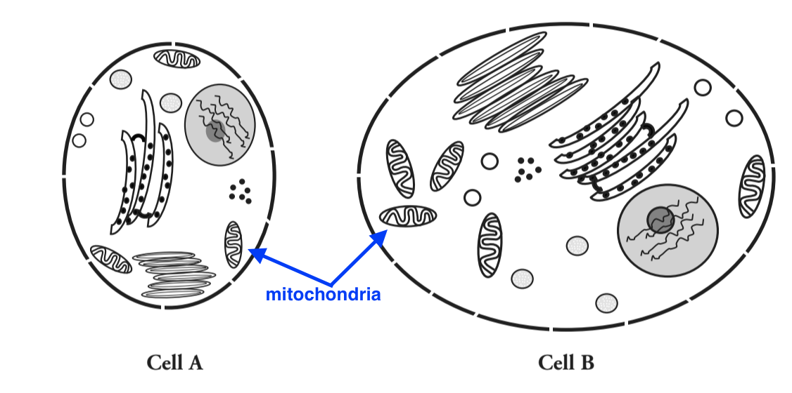

- Compare the smaller cell in Model 1 to the larger cell in Model 1.
a. Which cell has a larger surface area (more cell membrane surface)?
Cell B

b. Which cell has more channels in its cell membrane that can transport molecules (nutrients, oxygen, and waste products) in and out of the cell?
Cell B. 9 channels vs. 15 channels

- Compare the smaller cell to the larger cell in Model 1.
a. Which cell has more mitochondria?
Cell B
b. Propose an explanation for why the cell in part a would need more mitochondria for proper functioning of the cell.
The cell is larger and therefore needs more ATP energy to be made.

- What would be the consequences for a cell if the cell membrane was not large enough to have adequate channels for bringing in nutrients and removing waste?
The cell would NOT be able to make enough ATP without oxygen and sugars. It would also NOT have enough
material to make proteins. The cell could become too toxic if waste is not removed.

- Compare the smaller cell to the larger cell in Model 1.
a. Which cell has a larger volume?
Cell B

b. Imagine a glucose molecule entering the cell membrane. Would that molecule be able to reach the mitochondria
faster if the cell had a smaller volume or a larger volume? Explain.
A smaller volume because the glucose would be able to travel a shorter distance and not take as long.

c. As the mitochondria metabolize the glucose, they produce carbon dioxide waste. Would the CO₂ molecules be able to
leave the cell faster if the cell had a smaller volume or larger volume? Explain.
The CO₂ molecules would be able to leave the cell faster because it would have less distance to travel.

- Consider your answers to the previous questions. Is bigger always better for a cell? Explain.
NO. This is because a larger volume can take more time for nutrients and waste to either get to where they need
to or leave the cell.

Model 2 – Comparing Shapes
- Label the sets of shapes in Model 2 with each of the following: cubes, spheres, cylinders.
- Calculate the surface area-to-volume ratio for each shape in Model 2. One example is given in Model 1 for this calculation.
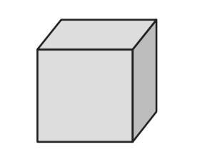
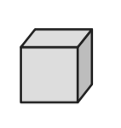
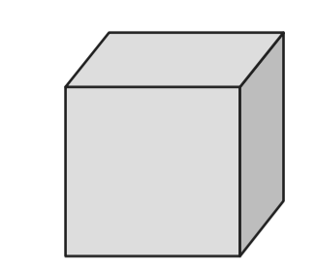

CUBES

Side | 1 cm | 2 cm | 4 cm
Surface area | 6 cm² | 24 cm² | 96 cm²
Volume | 1 cm³ | 8 cm³ | 64 cm³
Surface Area-to Volume Ratio | 6:1 | 3:1 | 96:64 =  1.5:1
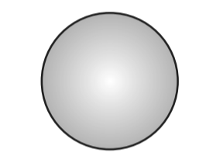


SPHERES

Diameter | 1 cm | 2 cm | 4 cm
Surface area | 3 cm² | 13 cm² | 50 cm²
Volume | 0.5 cm³ | 4.2 cm³ | 34 cm³
Surface Area-to Volume Ratio | 6:1 | 3.09:1 | 1.47:1
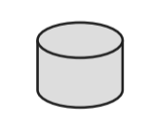
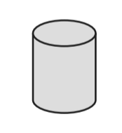
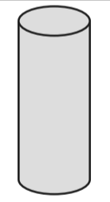

CYLINDERS

Diameter ×  Height | 1 cm × 1 cm | 1 cm × 2 cm | 1 cm × 4 cm
Surface area | 4.7 cm² | 7.9 cm² | 14 cm²
Volume | 0.8 cm³ | 1.6 cm³ | 3.1 cm³
Surface Area-to Volume Ratio | 4.7/0.8 = 5.87:1 | 4.98:1 | 4.51:1

- Consider the data in Model 2.
a. When a shape gets larger, which increases at a faster rate, surface area or volume?
VOLUME

- For all three of the shape sets, describe the change in the surface area-to-volume ratio as the size of the shape increases.
The ratio decreases (volume increases more rapidly)

- Considering your answer to Question 5, is it more desirable for a cell to have a small surface area-to-volume ratio or a large surface area-to-volume ratio? Explain your answer in terms of the functions of a cell.
Large surface area to volume ratio is MORE desirable because this allows more materials to get around the cell.

- Which two figures in Model 2 that have a similar surface area (within 1 cm² of each other). No, but Largest Cylinders and Middle Sphere are at 1cm.
a. Do the two figures have the same volume?
NO
b. Which shape has a more desirable surface area-to-volume ratio?
Cylinders (the ratio is slightly larger)

- In multicellular organisms some cells need to be large because of the functions they perform (i.e. nerve cells, muscle cells). What shape would be most desirable for these larger cells?
Cylinders (it has the best/largest surface area to volume ratio as each shape gets larger)

